# PNEUMVENT

# USER GUIDE

# Human Machine Interface

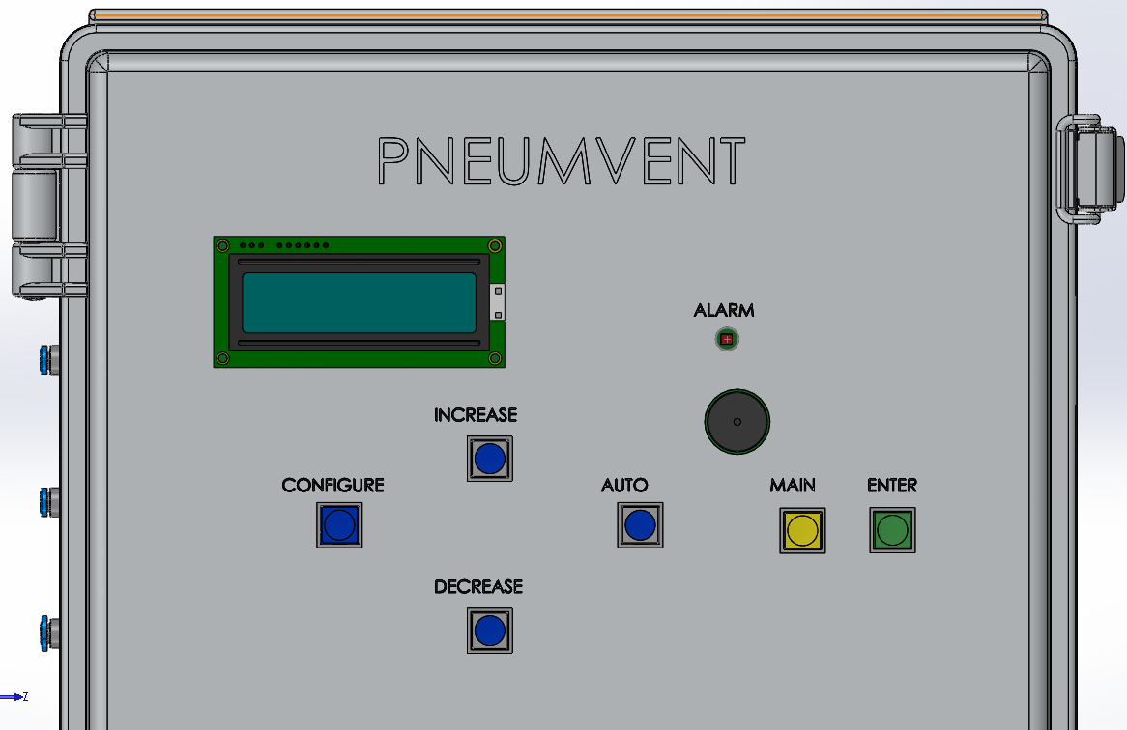

The system uses and LCD display to display system parameters as well as having six buttons for the user to interact with the system. The functions for the buttons are described below:

**CONFIGURE BUTTON-** It always the user to change the mode of operation of the system. At any time the user can change **three** control modes , namely:

1. Pressure
2. Frequency
3. Assisted

All three control modes have **13** parameters that are displayed or can be modified, namely:

1. **Mode of Operation**: Changes the control mode of the system to Pressure, Frequency or Assisted mode
2. **Temperature**: Displays the current system temperature inside the enclosure. This is necessary to ensure that the temperature drift is compensated for when measuring the sensor values
3. **Lower Tank Pressure:** Changes the lower pressure threshold for the oxygen tank. If the pressure drops below the specified value the alarm would go off.
4. **Tank High Pressure-** Changes the upper pressure threshold for the oxygen tank. If the pressure drops below the specified value the alarm would go off.
5. **Lung Pressure-** Displays the measured lung pressure
6. **Lower Lung Pressure:** Modifies the lower limit for the lung pressure. If the pressure drops below the specified value the alarm would go off.
7. **Higher Lung Pressure:** Modifies the upper limit for the lung pressure. If the pressure drops below the specified value the alarm would go off.
8. **Inspiration Percentage:** Modifies the inspiration percentage in a breathing cycle. This option is only available under Frequency Mode
9. **Respiration Time:** Modifies the patient’s total breaths per minute. This option is only available under Frequency Mode
10. **FiO2:** Modifies the total O2 percentage in the breathing mixture.
11. **Mixture Pressure:** Displays the total air pressure going into the patient
12. **Pressure Unit:** Converts the displayed pressure units to H20 cm, PSI, KPA,mbar and Hg mm.
13. **Temperature:** Converts the displayed pressure to Celsius or Fahrenheit

**ENTER BUTTON-**It is used to modify the system parameters. When the button is pressed a cursor on the LCD screen starts blinking. Whenever a cursor starts blinking you can modify the required parameters. The new parameters that you entered is only saved after you press the **ENTER** button again.

**INCREASE/DECREASE BUTTON-**  Pressing either buttons will display one of the 13 parameters mentioned above. If the **ENTER** button is pressed and the cursor is blinking , pressing the INCREASE/DECREAE button will increase or decrease the value of the blinking cursor.

**MAIN BUTTON-** Returns to the main display page (HOME) which displays most important parameters on a single screen, namely:FiO2, Mixture Pressure, and respiration time.

**AUTO BUTTON-**  Displays system parameters one at a time within 7 second interval.

# Breathing Controller:

Pneumvent can support 5 classifications of breathing which is controlled by the MCU. Those breathing classifications are displayed in the table below.

|  |  |
| --- | --- |
| Breathing Classification | Description |
| Time Cycle | Inspiration and expiration time is set at a certain timed threshold |
| Pressure Cycle | Inspiration cycle stops once a pressure threshold is reached |
| Flux Cycle | Inspiration cycle stops when aspiration flux drops below a pressure threshold |
| Volume Cycle | Inspiration cycle stops once a certain volume of gas has been inhaled |
| Custom Cycle | Any of the above cycles combined together |

# Alarm System

The alarm system is one of the critical indicators of Pneumvent and an alarm condition occurs when a set of fault condition is reached. A fault condition is reached when the sensor parameters are not within a predefined threshold. An example of an alarm triggering condition is when Pneumvent doesn’t detect an inspiration within a certain period of time.

In case of an alarm condition, a bright red LED on the front panel starts flashing as well as an audible buzzer goes off at 90dB. The volume level can be adjusted but only before the unit is built.